3.4 Technology Stack:
Technical Architecture:
The deliverable shall include the architectural diagram as below and the information as per the table1 & table2
Table-1: Components & Technologies:
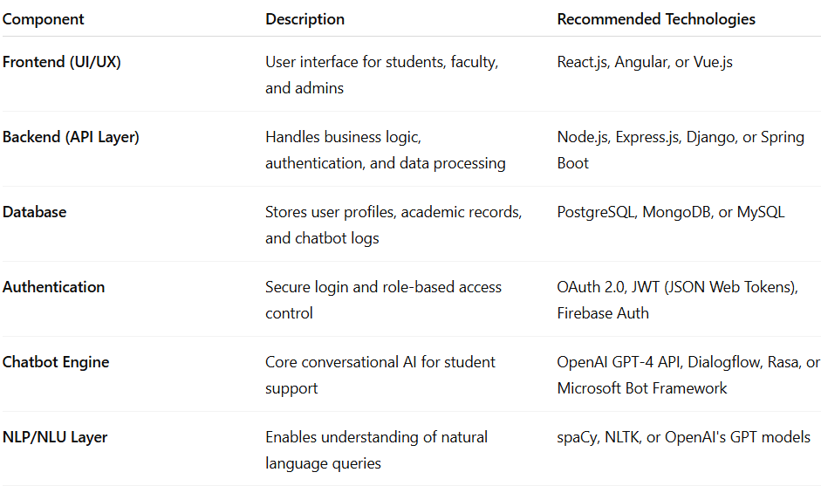Table2: Application Characteristics:
